Temasek Polytechnic
School of Informatics and IT

Diploma in Information Technology (IT)

Software Test Specifications (STS)

Project Particulars

Tutor | Mr Qi Yu Tao
Class | P01
Project Title | Delonix Regia Hotel Management System

Project Team’s Particulars

Matric Number | Student Name
1303140F | Jaelyn Lim Hui Wen
1303084F | Loh Shi Jia, Serene
1304174D | Leong Min En
1306932C | Reyner Leong

Revision History

Date | Version | Description | Author
27/5/15 | 1.1 | Update on Module development and unit testing | Loh Shi Jia, Serene
27/5/15 | 1.2 | Update on Module development and unit testing | Jaelyn Lim Hui Wen
28/5/15 | 1.3 | Update on System Integration | Leong Min En
29/5/15 | 1.4 | Update on Test Log | Loh Shi Jia, Serene
30/5/15 | 1.5 | Update on Test Log | Jaelyn Lim Hui Wen

Table of Contents

1. DISTRIBUTION OF WORKLOAD 5
2. MODULE DEVELOPMENT AND UNIT TESTING 5
2.1 <Room Availability and Booking Module> 5
2.2 <Reporting Module and CheckOut> 7
2.3 <HouseKeeping Module> 8
2.4 <Staff Management and User Module> 9
3 SYSTEM INTEGATION 10
4 TEST LOG 10
4.1 <Room Availability and Booking> (User ranges from receptionist, management and administrator) 10
4.2 <Management Form / Report Tab/ Room Details> 12
4.3 < Management Form / Report Tab/ Guest Details > 12
4.4 < Management Form / Report Tab/ Room Occupancy > 13
4.5 < Management Form / Report Tab/ Housekeeping Details > 13
4.6 < Management Form /Check-Out> 13
4.7 <Administration Form / Report Tab/ Room Details> 14
4.8 < Administration Form / Report Tab/ Guest Details > 14
4.9 < Administration Form / Report Tab/ Room Occupancy > 15
4.10 <Administration Form / Report Tab/ Housekeeping Details > 15
4.11 < Administration Form /Check-Out> 16
4.12 <Reception Form / Report Tab/ Room Details> 16
4.13 < Reception Form / Report Tab/ Guest Details > 16
4.14 < Reception Form /Check-Out> 17
4.15 Basic and Alternate Flows 17
4.16 Function 1 – Get All Duties 19
4.17 Function 2 – Create Duty 19
4.18 Function 3 – Retrieve Staff by Name 20
4.19 Function 4 – Update Staff Information 20
4.20 Scenario 5 21
4.21 Function 1 – Staff Under Management 22
4.22 Function 2 – User Under Management 22
4.23 Function 3 – Staff under Administrator 23
4.24 Function 4 – Staff under Administrator 24
4.25 Function 5 – User Under Administrator 24
4.26 Function 6 – User Under Administrator 25

DISTRIBUTION OF WORKLOAD

Construction & Testing | Members
MODULE DEVELOPMENT AND UNIT TESTING | 1303140F Jaelyn Lim Hui Wen  1303084F Loh Shi Jia, Serene
SYSTEM INTEGATION | 1304174D Leong Min En
TEST LOG | 1303140F Jaelyn Lim Hui Wen  1303084F Loh Shi Jia, Serene

MODULE DEVELOPMENT AND UNIT TESTING

<Room Availability and Booking Module>
There is simplicity implemented into the software to ensure quality and efficiency through Tab Controls. The process of the room booking is through the:
- Home Tab: where the user will enter the check in and check out dates and select the preferred room type of the guest or if they allow the user to choose any suggestion wise. Then once the retrieve button is clicked, it will check with the database if the date range has any existing bookings, if so it will take in the rest of the information and display it into the datagrid. The user then can select whichever room using the checkbox and clicking on booking. They will be redirected to the Reservation tab.

- Reservation Tab: this is where the user will enter the details of the guests, once the user clicks on submit, all information will be taken in, not forgetting the dates and room type from the previous tab into the database server. Here, entering Additional Requirements is optional.

- Check In Tab: this tab allows the user to search for any guest details that they require in order to check in or to update and delete. They can search by either guest number, last name, check in and check out date. When they click find all button, all details of guest will be display for selection at the datagrid. Once the search button is clicked, it will reference the entered details with those in the database and if there is more than one entry then it will be displayed in the datagrid, else it will display in a groupbox. This groupbox takes information from two tables which are the Guest and Booking table. When Check In is clicked, it will take in any changed information and set the current room status to ‘Occupied’. If update guest details is clicked another groupbox appears with all the guest details displayed in textboxes for them to edit, here they can either update or choose to delete the guest in case somebody backs out or if they want to use a different credit card for payment.

As for the testing method Parameterized Unit Testing and Unit Testing limitations is being used. The PUT are tests that take the parameters into account because these parameters could be manually entered but are also sometimes created by the framework. And for the Unit Testing limitation, testing does not always trace every error in the program, writing the unit test proved to be difficult but useful. Creating relatable scenarios and checks so that the program works like how it is supposed to and its expected results. Black Box testing is also used to see if the values created or updated are followed through to the database.

Good Coding Practices that were used:
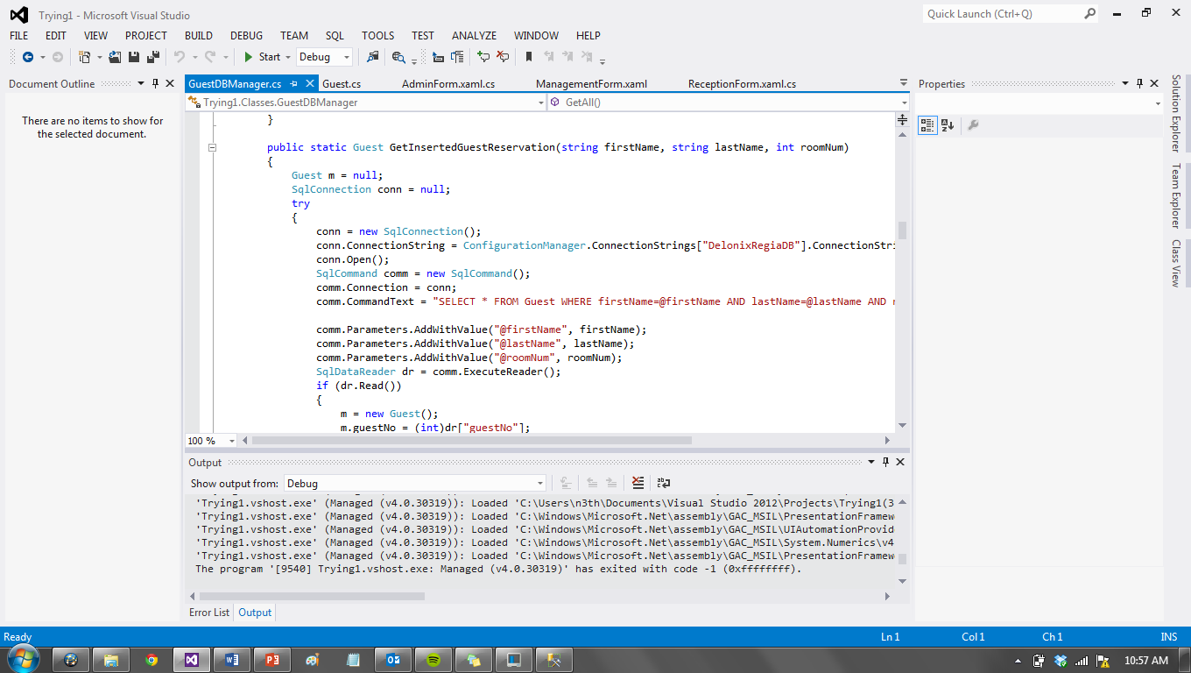
- Good Programming Style using Lower Camel Case for variables and Upper Camel Case for methods.
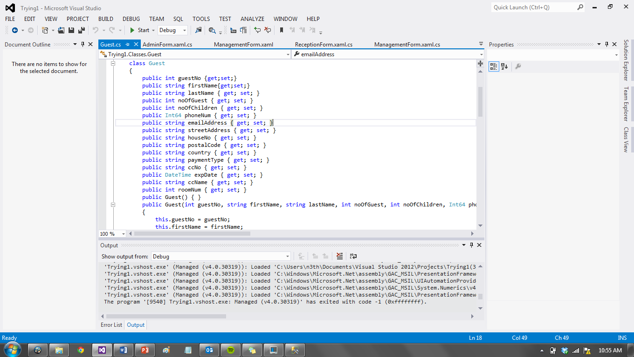

- Next-Line Code Layout Style
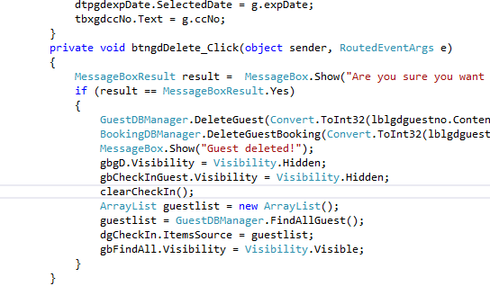

- Code Refactoring
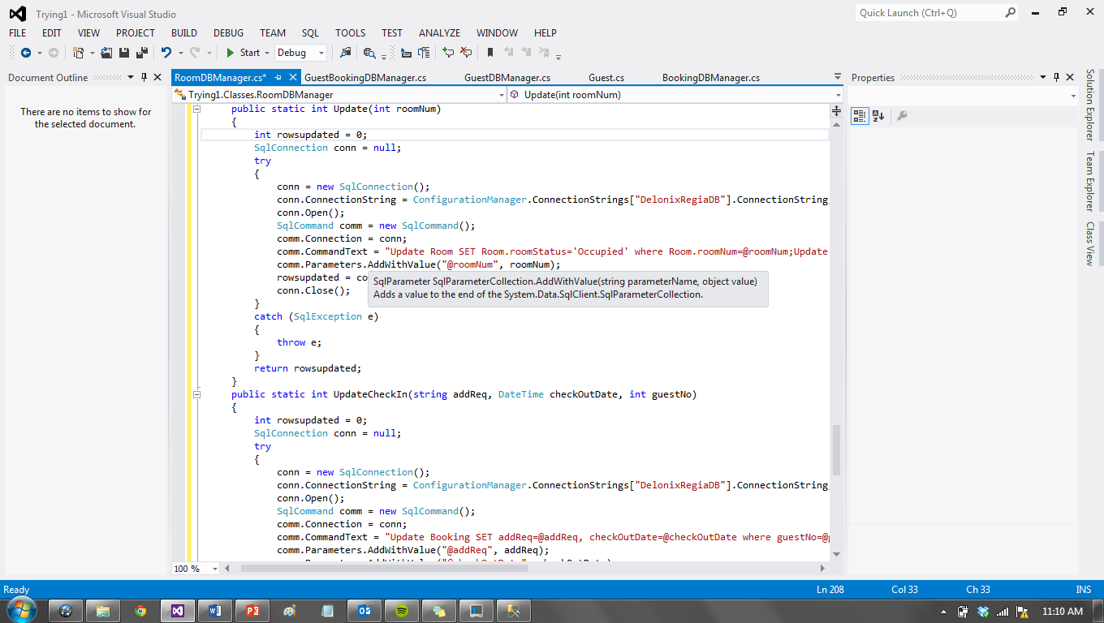
Becomes
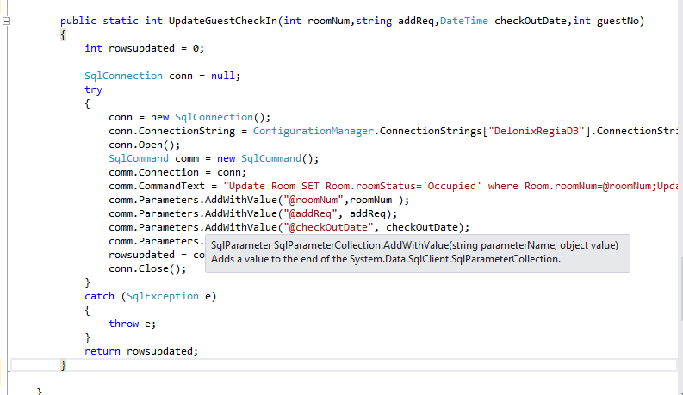

Using the SQL statement to combine together:
“Update Room SET Room.roomStatus='Occupied' where Room.roomNum=@roomNum;Update Booking SET addReq=@addReq, checkOutDate=@checkOutDate where guestNo=@guestNo;”

Unified Process is used to test the system continuously after each function. For example, after the check in coding is done, the program will be run to test if there are any errors.
For some functions if there is no input the program will prompt an error message to state that there is a need for re-input from the user.

<Reporting Module and CheckOut>
I decided to use the process of Unified Process (UP) aka iterative model. This model divides the whole SDLC into smaller, more easily manageable iterations.
This multiple development cycle is also known as the “multi-waterfall” cycle. Each iteration will then pass through the requirements phases.

This will allow a working version of the software to be produced during the first iteration, so that a working system is available early on during the software life cycle. Subsequent iterations will aim to build on the initial software produced during the first iteration.

And during each iteration I ensured that I upgraded the software as per the requirements. During the second iteration I completed the Reports tab and functions.
During the third iteration, I completed the checkout and payment tab and functions.

For testing I used black box testing in which all the basic functions were tested with data given and all functions were working properly

Modules done:
- Report Functions
- Checkout Functions

<HouseKeeping Module>
This module has been developed for both the management and the administrator.
They are able to create, retrieve, update and delete a certain duty. While developing this module, I have followed the ‘Waterfall’ methodology which consists of;
- Requirements
- Analysis/Design
- Coding
- Testing
- Deployment
After making a trip from the top to the bottom, the process will then head back to the top.

Requirements

- All five functions (Create, Retrieve, Update & Delete) are required

- Both Management users and Administrator are able to retrieve all housekeeping duties from the database

- Both Management users and Administrator are able to create new housekeeping duties

- Both Management users and Administrator are able to update current duties that are in the database

- Both Management users and Administrator are able to delete duties from the database

Analysis/Design
For the function design, the ‘easy flow’ of usage of the application was taken into consideration. It was first hand drawn on a piece of paper which would then have additional things if necessary.

Coding

Individual function’s codes will be first researched on. Once the research is done, coding will be programmed separately and will then be put together in the sub-section tabs in the system.
Codes must be taken into consideration as to which user have access to what functions.
The codes will be done in Microsoft Visual Studio 2013 which would then link up to Microsoft Sql Server 2012.

Testing

Once the codes are done, testing phase will occur. The testing will be done with reference to the Test Logs.

Deployment

Once it is tested, it will be then sent for deployment for users to try in order to gather feedbacks.

<Staff Management and User Module>
The first step in preparing to do module development is to set up development environment. Since we use Subversion for source code version control and divided the systems, I installed AnkhSVN and DiffMerge for version control and manage conflicts into Visual Studio. Besides, based on database design, I created tables as required for staff such as staff name, staff number, address, phone number etc…

Create the Module
At the beginning of creating module, I divided Staff and User for different sub module. First one is search staff and user under management and then follow up by update, create and delete in administrator. Then, I added a connection string named DelonixRegiaConnectionString into App.config under our system. The next step is create the forms required such as create staff and user, delete and update staff and user and staff and staffdbManager. Next, I created forms based on the order of sub modules, once a form is created, the testing is performed.

SYSTEM INTEGATION

There are two parts that will be needed to be integrated which are front-end module and back-end module. This two component will form the system. We will be employing an incremental testing strategy to complete the integration.

- Front-end module
This module give a simple interface where the user is able to perform different functions. This module will check if each interface such as buttons is working properly. The testing will be performed by writing stub for the interface.

- Back-end module
The back-end module will provide storage for the data and implement related function in the system. This module will run the program and print out the results to the output.
The front end and back end module will interact together will complete accuracy .

TEST LOG

<Room Availability and Booking> (User ranges from receptionist, management and administrator)
S/No | Steps | Test Data | Expected Results | Actual Results | Remarks
1 | Select booking details | User inputs check in, check out dates and room Type and clicks Retrieve.  Normal data | Information will be displayed according to date range availability and room type | Information is displayed according to date range availability and room type | Guest may or may not have a specified room type, so every room is available accordingly
2 | Book according to booking details | User selects a checkbox corresponding to a certain room.  Normal Data | Information will be transferred and user will be redirected to Reservation page with room number label filled. | Information is transferred and user is redirected to Reservation page with room number label filled.
3 | Guest Details | User inputs guest details for creation.  Normal Data | When submit button is clicked, guest information will be created and an entry will be created under booking with the dates and additional requirements. | When submit button is clicked, guest information is created and an entry is created under booking with the dates and additional requirements.
4 | Search for Guest | User inputs any of the four details and clicks Search.  Normal Data | If there is more than one data it will display in the datagrid, else it will display in a groupbox. | If there is more than one data it displays in the datagrid, else it displays in a groupbox.
5 | Search All Guests | User clicks on find all button | It will display in a datagrid | It displays in a datagrid
6 | Check In Guest | User can enter add requirements or change their check out date.  Normal Data | User clicks on Check In and the room status changes to ‘Occupied’ and update database if changes are made | User clicks on Check In and the room status changed to ‘Occupied’ and update database because changes were made
7 | Update Guest Details | User clicks on button and redirected to groupbox with details in textbox and click update. | The information can be changed and the database will update and redirect back to the datagrid with changed information. | The information is changed and the database updates and redirects back to the datagrid with changed information. | Delete can also be done here
8 | Delete Guest | User clicks on delete | The information will be displayed in a message box and asks for confirmation of deletion. | The information displayed in a message box and asked for confirmation of deletion and redirected to the updated datagrid. | The cancelling can be canceled.
Exception Flows
9 | Step1’s alternate flow, user click on retrieve | when user clicks retrieve without entering any information | A message box will pop up prompting the user to enter information | A message box pops up prompting the user to enter information
10 | Step 4’s alternate flow,  User clicks on search | User clicks on search without entering any information | A message box will pop up prompting the user to enter information | A message box pops up prompting the user to enter information

<Management Form / Report Tab/ Room Details>
S/No | Steps | Test Data | Expected Results | Actual Results | Remarks
1 | Click on “Get All Room Info” button | Nil | All room info is displayed on the datagrid: dGRooms. | All room info is displayed on the datagrid: dGRooms. | Successful
2 | Select a room number on combobox: cBoxSelectRoom | 1 | Information about room 1 is displayed | Information about room 1 is displayed | Successful
3 | Click on any other tab | Nil | Redirect screen to respective tab | Redirect screen to respective tab | Successful

< Management Form / Report Tab/ Guest Details >
S/No | Steps | Test Data | Expected Results | Actual Results | Remarks
1 | Select a room number on combobox: cBoxGuestRoom | 1 | All guest info is displayed on the datagrid: DGGuests | All guest info is displayed on the datagrid: DGGuests | Successful
2 | Select a date number on combobox: dPickGuestDate | 2013-06-06 | Information about guest is displayed | Information about guest is displayed | Successful
3 | Click on any other tab | Nil | Redirect screen to respective tab | Redirect screen to respective tab | Successful

< Management Form / Report Tab/ Room Occupancy >
S/No | Steps | Test Data | Expected Results | Actual Results | Remarks
1 | Select a date on combobox: dPickDate1 | 2013-06-01
2 | Select a date on combobox: dPickDate2 | 2013-06-30
3 | Click on “Select Dates” button | Nil | All booking info is displayed on the datagrid: dGRoomOccupancy | All booking info is displayed on the datagrid: dGRoomOccupancy | Successful

< Management Form / Report Tab/ Housekeeping Details >
S/No | Steps | Test Data | Expected Results | Actual Results | Remarks
1 | Select a date on combobox: dPickDate1 | 2013-06-01
2 | Select a date on combobox: dPickDate2 | 2013-06-30
3 | Click on “Select Dates” button | Nil | All housekeeping info is displayed on the datagrid: dGHousekeeping | All housekeeping info is displayed on the datagrid: dGRHousekeeping | Successful

< Management Form /Check-Out>
S/No | Steps | Test Data | Expected Results | Actual Results | Remarks
1 | Select a roomNo on combobox: cBoxPaymentRoom | 1 | GuestNo and BookingID will be shown on data grid dGbookingDetails | GuestNo and BookingID will be shown on data grid dGbookingDetails | Successful
2 | Select a guestNo on combobox:  cBoxGuestNo | 1 | lblCardholderName, lblCardholderNo and lblExpiryDate will be populated from database | lblCardholderName, lblCardholderNo and lblExpiryDate will be populated from database | Successful
3 | Click on “Submit” button | Nil | Invoice table in database is populated with relevant information  gbInvoice is populated with information | Invoice table in database is populated with relevant information  gbInvoice is populated with information | Successful

<Administration Form / Report Tab/ Room Details>
S/No | Steps | Test Data | Expected Results | Actual Results | Remarks
1 | Click on “Get All Room Info” button | Nil | All room info is displayed on the datagrid: dGRooms. | All room info is displayed on the datagrid: dGRooms. | Successful
2 | Select a room number on combobox: cBoxSelectRoom | 1 | Information about room 1 is displayed | Information about room 1 is displayed | Successful
3 | Click on any other tab | Nil | Redirect screen to respective tab | Redirect screen to respective tab | Successful

< Administration Form / Report Tab/ Guest Details >
S/No | Steps | Test Data | Expected Results | Actual Results | Remarks
1 | Select a room number on combobox: cBoxGuestRoom | 1 | All guest info is displayed on the datagrid: DGGuests | All guest info is displayed on the datagrid: DGGuests | Successful
2 | Select a date number on combobox: dPickGuestDate | 2013-06-06 | Information about guest is displayed | Information about guest is displayed | Successful
3 | Click on any other tab | Nil | Redirect screen to respective tab | Redirect screen to respective tab | Successful

< Administration Form / Report Tab/ Room Occupancy >
S/No | Steps | Test Data | Expected Results | Actual Results | Remarks
1 | Select a date on combobox: dPickDate1 | 2013-06-01
2 | Select a date on combobox: dPickDate2 | 2013-06-30
3 | Click on “Select Dates” button | Nil | All booking info is displayed on the datagrid: dGRoomOccupancy | All booking info is displayed on the datagrid: dGRoomOccupancy | Successful

<Administration Form / Report Tab/ Housekeeping Details >
S/No | Steps | Test Data | Expected Results | Actual Results | Remarks
1 | Select a date on combobox: dPickDate1 | 2013-06-01
2 | Select a date on combobox: dPickDate2 | 2013-06-30
3 | Click on “Select Dates” button | Nil | All housekeeping info is displayed on the datagrid: dGHousekeeping | All housekeeping info is displayed on the datagrid: dGRHousekeeping | Successful

< Administration Form /Check-Out>
S/No | Steps | Test Data | Expected Results | Actual Results | Remarks
1 | Select a roomNo on combobox: cBoxPaymentRoom | 1 | GuestNo and BookingID will be shown on data grid dGbookingDetails | GuestNo and BookingID will be shown on data grid dGbookingDetails | Successful
2 | Select a guestNo on combobox:  cBoxGuestNo | 1 | lblCardholderName, lblCardholderNo and lblExpiryDate will be populated from database | lblCardholderName, lblCardholderNo and lblExpiryDate will be populated from database | Successful
3 | Click on “Submit” button | Nil | Invoice table in database is populated with relevant information  gbInvoice is populated with information | Invoice table in database is populated with relevant information  gbInvoice is populated with information | Successful

<Reception Form / Report Tab/ Room Details>
S/No | Steps | Test Data | Expected Results | Actual Results | Remarks
1 | Click on “Get All Room Info” button | Nil | All room info is displayed on the datagrid: dGRooms. | All room info is displayed on the datagrid: dGRooms. | Successful
2 | Select a room number on combobox: cBoxSelectRoom | 1 | Information about room 1 is displayed | Information about room 1 is displayed | Successful
3 | Click on any other tab | Nil | Redirect screen to respective tab | Redirect screen to respective tab | Successful

< Reception Form / Report Tab/ Guest Details >
S/No | Steps | Test Data | Expected Results | Actual Results | Remarks
1 | Select a room number on combobox: cBoxGuestRoom | 1 | All guest info is displayed on the datagrid: DGGuests | All guest info is displayed on the datagrid: DGGuests | Successful
2 | Select a date number on combobox: dPickGuestDate | 2013-06-06 | Information about guest is displayed | Information about guest is displayed | Successful
3 | Click on any other tab | Nil | Redirect screen to respective tab | Redirect screen to respective tab | Successful

< Reception Form /Check-Out>
S/No | Steps | Test Data | Expected Results | Actual Results | Remarks
1 | Select a roomNo on combobox: cBoxPaymentRoom | 1 | GuestNo and BookingID will be shown on data grid dGbookingDetails | GuestNo and BookingID will be shown on data grid dGbookingDetails | Successful
2 | Select a guestNo on combobox:  cBoxGuestNo | 1 | lblCardholderName, lblCardholderNo and lblExpiryDate will be populated from database | lblCardholderName, lblCardholderNo and lblExpiryDate will be populated from database | Successful
3 | Click on “Submit” button | Nil | Invoice table in database is populated with relevant information  gbInvoice is populated with information | Invoice table in database is populated with relevant information  gbInvoice is populated with information | Successful

Basic and Alternate Flows
Basic Flow for Reporting
Room Details
  - This use case starts when a Staff accesses the Reporting tab.
  - The system displays combo box list of all Rooms
  - The System displays a button “Get all Room Info”
Basic Flow
- (step1) Click on button
- (step2) System displays all room info on a datagrid
Alternate flow
- A1) Select Room Number on Combo box
- A2) System displays room information

Room Guest Details
  - This use case starts when a Staff accesses the subtab Guest Details in the Reporting tab.
  - The system displays combo box list of all Rooms
  - The System displays a button datePicker
Basic Flow
- (step1) Select a room number on combo box
- (step2) System displays all guest information on a datagrid
Alternate flow
- A1) Select Date on Datepicker
- A2) System displays guest information on a datagrid

Room Occupancy
  - This use case starts when a Staff accesses the subtab Room Occupancy. The system displays 2 datepickers
Basic Flow
- (step1) Staff Selects 2 dates in the datepickers and clicks on the button
- (step2) System displays all room occupancy report
Housekeeping
  - This use case starts when a Staff accesses the subtab housekeeping The system displays 2 datepickers
Basic Flow
- (step1) Staff Selects 2 dates in the datepickers and clicks on the button
- (step2) System displays all housekeeping information

Function 1 – Get All Duties
S/No | Steps | Test Data | Expected Results | Actual Results | Remarks
1 | Click on the ‘Duties’ tab | Pass | Duties tab appear | Duties tab appear
2 | Under ‘Duties’ sub-tab click on Get All Duties Button | Pass | Retrieved all data from database | Retrieved all data from database

Function 2 – Create Duty
S/No | Steps | Test Data | Expected Results | Actual Results | Remarks
1 | Click on the ‘Duties’ tab | Pass | Duties tab appear | Duties tab appear
2 | Under ‘Create Duty’ sub-tab click on Create button | Fail | Error stating to fill in all required fields | Error stating to fill in all required fields | Error message pops up
3 | Fill in Name and leave the rest blank. Press the ‘Create’ button | Fail | Error stating to fill in all required fields | Error stating to fill in all required fields | Error message pops up
4 | Fill in Name, date assigned and leave duty assigned blank. Press the ‘Create’ button | Fail | Error stating to fill in all required fields | Error stating to fill in all required fields | Error message pops up
5 | Fill in all blanks and press the ‘Create’ button | Pass | Create successfully message will pop up | Create successfully message will pop up | Create and written to database

Function 3 – Retrieve Staff by Name
S/No | Steps | Test Data | Expected Results | Actual Results | Remarks
1 | Click on ‘Updates’ sub-tab and press the ‘Retrieve’ button | Fail | Error stating to fill in staff name pops up | Error stating to fill in staff name pops up | Error message pops up
2 | Fill in a name which cannot be found in database and press ‘Retrieve’ button | Fail | Error stating that name is not found | Error stating that name is not found | Error message pops up
3 | Fills in a name that is in the Database and press ‘Retrieve’ button | Pass | No error, data is received and displayed in the textboxes and label below | No error, data is received and displayed the information in the textbox and label provided | All data is retrieve

Function 4 – Update Staff Information
S/No | Steps | Test Data | Expected Results | Actual Results | Remarks
1 | Click on ‘Updates’ sub-tab and press the ‘Retrieve’ button | Fail | Error stating to fill in staff name pops up | Error stating to fill in staff name pops up | Error message pops up
2 | Fill in a name which cannot be found in database and press ‘Retrieve’ button | Fail | Error stating that name is not found | Error stating that name is not found | Error message pops up
3 | Fills in a name that is in the Database and press ‘Retrieve’ button | Pass | No error, data is received and displayed in the textboxes and label below | No error, data is received and displayed the information in the textbox and label provided | All data is retrieve
4 | Make changes to the Name and press ‘Update’ button | Pass | Name have been modified | Changes have been updated successfully | Updated the data in the database
5 | Make changes to the Date and press ‘Update’ button | Pass | Date have been modified | Changes have been updated successfully | Updated the data in the database
6 | Make changes to the Duty that has been assigned and press ‘Update’ button | Pass | Duty Assigned have been modified | Changes have been updated successfully | Updated the data in the database

Scenario 5
S/No | Steps | Test Data | Expected Results | Actual Results | Remarks
1 | Click on ‘Updates’ sub-tab and press the ‘Retrieve’ button | Fail | Error stating to fill in staff name pops up | Error stating to fill in staff name pops up | Error message pops up
2 | Fill in a name which cannot be found in database and press ‘Retrieve’ button | Fail | Error stating that name is not found | Error stating that name is not found | Error message pops up
3 | Fills in a name that is in the Database and press ‘Retrieve’ button | Pass | No error, data is received and displayed in the textboxes and label below | No error, data is received and displayed the information in the textbox and label provided | All data is retrieve
4 | Press the ‘Delete’ Button | Pass | Data deleted | All data regarding the housekeeper have been deleted from the database | Data have been removed from the database

Function 1 – Staff Under Management
S/No | Steps | Test Data | Expected Results | Actual Results | Remarks
1 | Click on the ‘Staff’ tab Under Management | Pass | Staff tab appear | Staff tab appear
2 | Under ‘Staff’ in Management click on Search Button | Pass | Retrieved all staff data from database entering by staff name | Retrieved all staff data from database
3 | Under ‘Staff’ in Management click on Update Button | Pass | Selected fields in the database under staff will be update | Selected fields in the database under staff will be update

Function 2 – User Under Management
S/No | Steps | Test Data | Expected Results | Actual Results | Remarks
1 | Click on the ‘User’ tab Under Management | Pass | User tab appear | User tab appear
2 | Under ‘User” in Management click on Search Button | Pass | Retrieved user username and password by user number from database | Retrieved user username and password by user number from database
3 | Under ‘User’ in Management click on Update Button | Pass | Selected fields in the database under user will be update | Selected fields in the database under staff will be update
…

Function 3 – Staff under Administrator

S/No | Steps | Test Data | Expected Results | Actual Results | Remarks
1 | Click on the ‘Staff’ tab Under Administrator | Pass | Staff tab appear | Staff tab appear
2 | Under ‘Staff” in Administrator click on Search Button | Pass | Retrieved all staff data from database entering by staff name | Retrieved all staff data from database entering by staff name
3 | Under ‘Staff’ in Administrator click on Update Button | Pass | Selected fields in the Administrator under staff will be update and also in the database | Selected fields in the Administrator under staff will be update and also in the database
4 | Under ‘Staff’ in Administrator click on Delete Button | Pass | Selected fields in the Administrator under staff will be deleted and also will be deleted from the database | Selected fields in the Administrator under staff will be deleted and also will be deleted from the database

Function 4 – Staff under Administrator
S/No | Steps | Test Data | Expected Results | Actual Results | Remarks
1 | Click on the ‘Staff’ tab Under Administrator | Pass | Staff tab appear | Staff tab appear
2 | Under ‘Create” in Administrator click on Create Button | Pass | A new Staff will be created in the database by filling in the requirement in the Administrator create form | A new Staff will be created in the database by filling in the requirement in the Administrator create form

Function 5 – User Under Administrator
S/No | Steps | Test Data | Expected Results | Actual Results | Remarks
1 | Click on the ‘User’ tab Under Administrator | Pass | User tab appear | User tab appear
2 | Under ‘User” in Administrator click on Search Button | Pass | Retrieved all staff data from database by entering your own staff number | Retrieved all staff data from database by entering your own staff number
3 | Under ‘User “in Administrator click on Update Button | Pass | Selected fields in the Administrator under User will be update and also in the database | Selected fields in the Administrator under User will be update and also in the database
4 | Under ‘User’ in Administrator click on Delete Button | Pass | Selected fields in the Administrator under User will be deleted and also will be deleted from the database | Selected fields in the Administrator under User will be deleted and also will be deleted from the database

Function 6 – User Under Administrator
S/No | Steps | Test Data | Expected Results | Actual Results | Remarks
1 | Click on the ‘User” tab Under Administrator | Pass | User tab appear | Staff tab appear
2 | Under ‘Create” in Administrator click on Create Button | Pass | A new User will be created in the database by filling in the requirement in the Administrator create form | A new User will be created in the database by filling in the requirement in the Administrator create form

